A picture is worth a thousand words:

What’s Going on in This Figure?

Figures are a graphical display of data obtained in a scientific investigation or study. Figures are very effective at communicating research findings but sometimes this pictorial format can lead to different conclusions than the investigators implied, or can lead to confusion, or to further questions. Below are a series of figures obtained from scientific studies or from news websites regarding COVID-19. Examine the figures carefully. Think about what information is being conveyed by the figure. I purposely did not include the figure legends that accompany the figures because I want you to come to your own conclusions, not necessarily what the author(s) of the figure wants you to see. I, therefore, also did not include the citation for the figure to try to prevent you from looking up the figure. All of these figures can be freely accessed via the internet. Each figure is accompanied with questions for you to consider. Some questions require you to look up the answers; some are interpretations of the figure. You should look up the meaning of bolded terms.

Figure 1. Onset of Illness among the First 425 Confirmed Cases of Novel Coronavirus (2019-nCoV)–Infected Pneumonia (NCIP) in Wuhan, China.

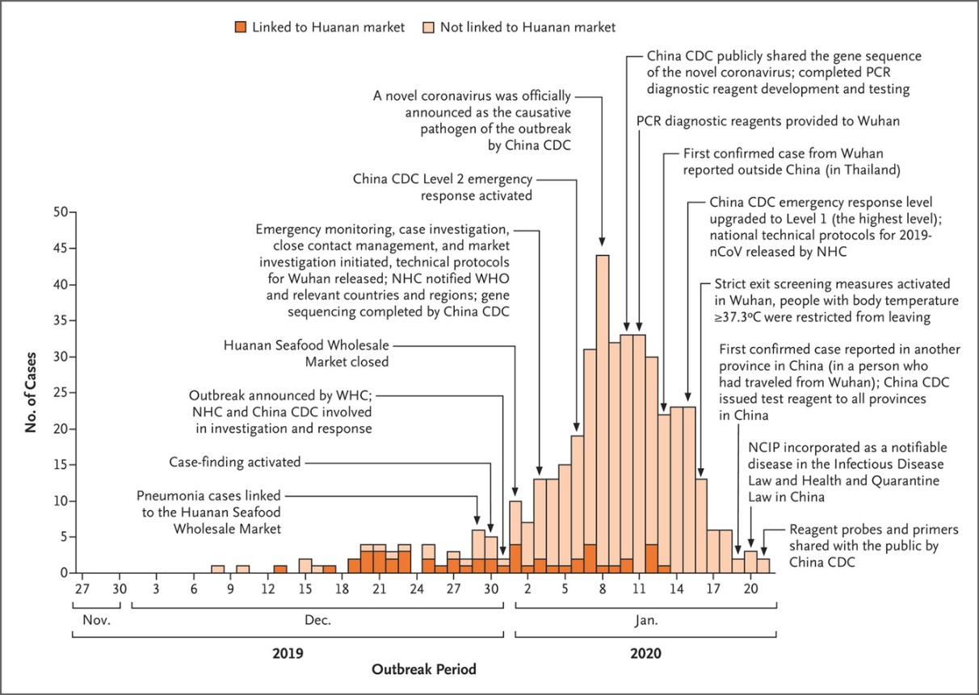
- What is the difference between morbidity and mortality? What are the demographics of this disease, at least so far?

- Children appear to be spared from this disease or their illness is subclinical. Why is this subclinical presentation problematic?

- How is a “case fatality” rate calculated? Why is it difficult to calculate a case fatality rate?

- What is the reproduction number, R₀? Why does an R₀ <1 indicate that an infection is not spreading? Examining the figure, would you expect the R₀ to be <1 or >1?

- Examine the number of cases after Jan. 11. Although cases declined and exit screening was in place in Wuhan, what do the two red boxed statements imply with respect to transmission?

Figure 2. Healthcare system capacity.

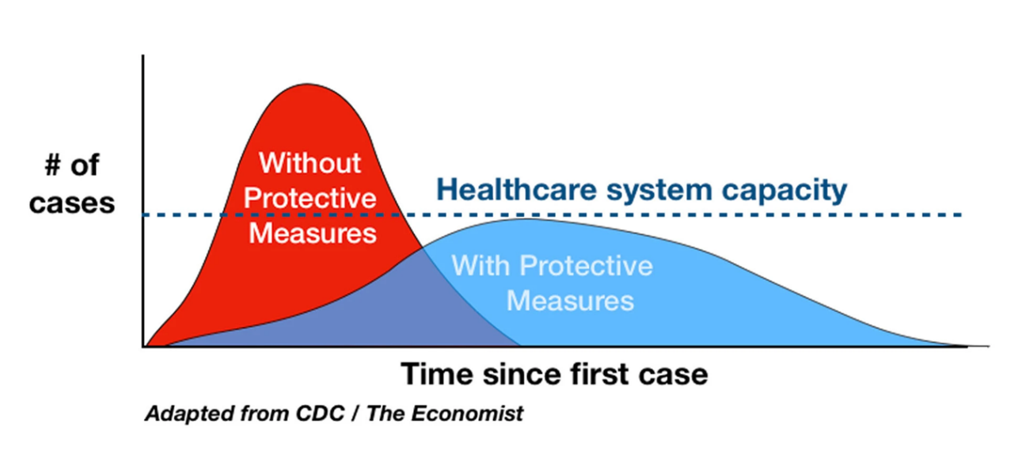

We see this figure constantly and hear the mantra, “flatten the curve”. But what does this really mean? Examine the figure carefully.

- What happens to the amount of time the disease is impacting the population when the curve is flattened?

- Protective measures are meant to stop the spread of the disease. However, this also means that fewer people are getting sick with the disease. Sounds great! But, as the infection rate goes down, fewer people develop immunity to the virus and herd immunity will be lacking. What would then happen if/when these protective measures are lifted?

- There is another thing besides protective measures that could be done. What is it? (See: https://www.thelancet.com/journals/lanpub/article/PIIS2468-2667(20)30074-8/fulltext; https://jamanetwork.com/journals/jamainternalmedicine/fullarticle/2764369 )

Figure 3. Total confirmed deaths

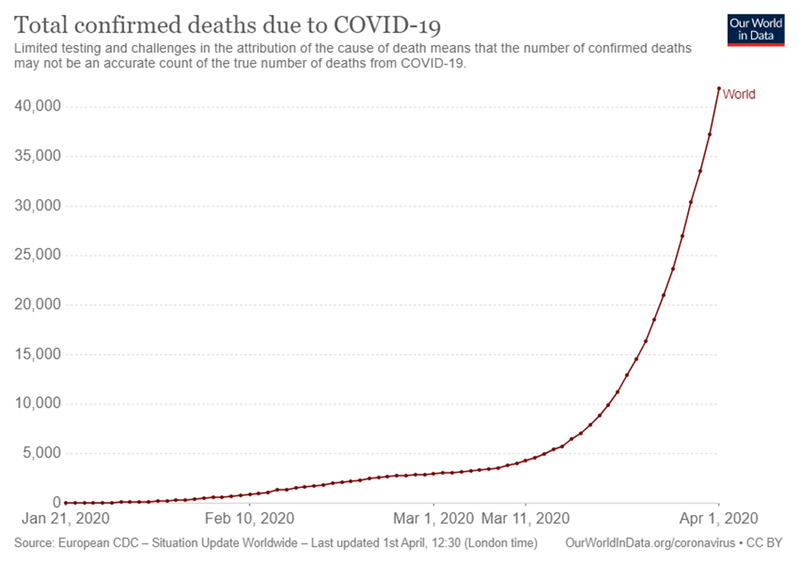
- Explain why the lack of testing makes this figure difficult to interpret.

- In addition, what is the challenge in attributing a cause of death to COVID-19? Think about the demographics of the disease.

Figure 4. Spread of COVID-9
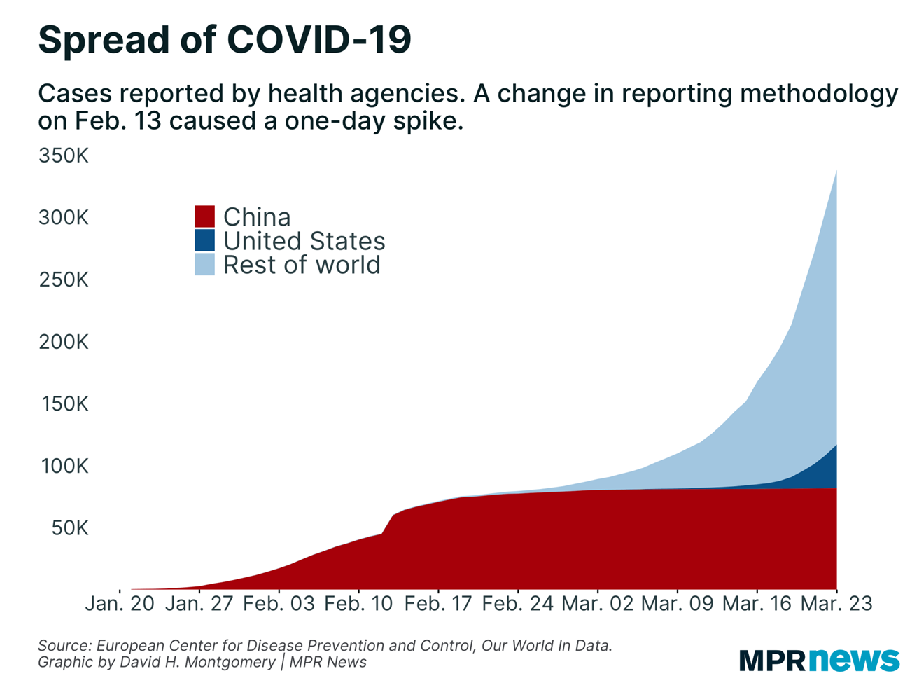

This figure reflects the number of cases reported to the World Health Organization.

- Explain why is there a slow rise in cases in the United States compared to cases in the rest of the world.

- Why are figures like this not accurate with respect to numbers of actual cases?

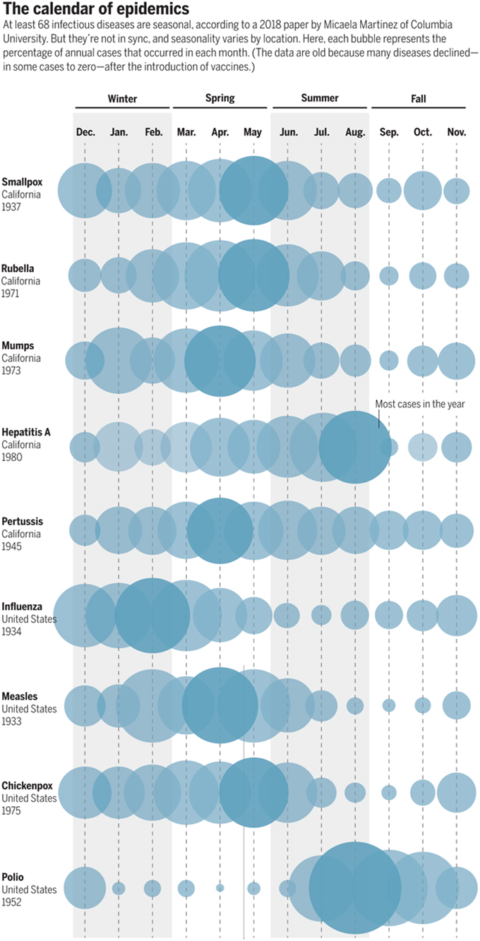

Figure 5.
This figure shows the incidence of 9 different infectious diseases according to months of the year from https://www.sciencemag.org/news/2020/03/why-do-dozens-diseases-wax-and-wane-seasons-and-will-covid-19
These epidemics display a seasonal variation. What is also interesting is that viral diseases such as smallpox, rubella, mumps, influenza, chickenpox, and polio, are all caused by viruses that have envelopes. The viruses that cause hepatitis A and polio do not have envelopes and occur at different times of the year than diseases due to enveloped viruses. The common cold can occur at any time of the year and most colds are due to nonenveloped rhinoviruses and adenoviruses.
What does this seasonality imply about the differences between viruses with and without envelopes? (We will discuss what an envelope is later in the course.)

Figure 6:

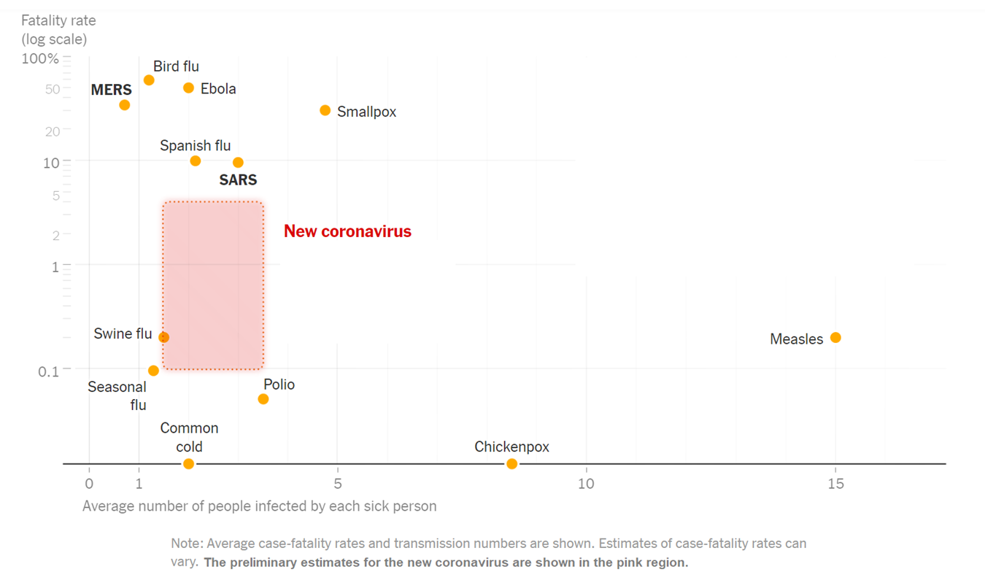
How infectious is the “new coronavirus” compared to these other viral illnesses? How deadly?

