PHYSICS 2: Homework 1
- In the figure below, the electric field lines at point B have twice the separation of those at point A. (a) If the magnitude of the field at A is 40 N/C, what is the magnitude of the electrostatic force acting on a proton at point A? (b) What is the magnitude of the electric field at point B?

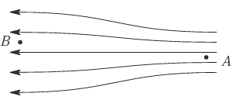

- The nucleus of a plutonium (Pu) atom contains 94 protons. Assume that the nucleus is a sphere with radius 6.64×10⁻¹⁵ m and with the charge of the protons uniformly spread throughout the sphere. At the surface of the nucleus, what are the (a) magnitude and (b) direction (radially inward or outward) of the electric field due to the nucleus

- An electron is accelerated eastward at 1.80 × 10⁹ m/s² by an electric field. Determine the (a) magnitude and (b) direction of the electric field.

