Flux
New concept, very general idea.
Imagine you have a porous filter held in a rectangular frame, and air passes through the filter.

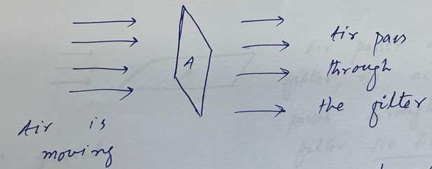

Now the flux is defined as the amount of air that passes through the filter per unit time. It is represented by Greek letter ϕ.

Φ = Greek Letter (phi)

From the figure, we can see that flux is directly proportional to V , A and also the orientation of the filter with respect to the flow of the air.
If the air is faster, the flux increases. if the area of the filter is larger, then flux will also increase.
What about the angle (orientation of the filter)?

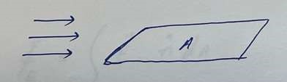
In the above figure, air passes around the filter, but no air passes through the filter. this means flux passing through the filter is zero.
In general, the filter can be at any orientation, as shown in the figure below:

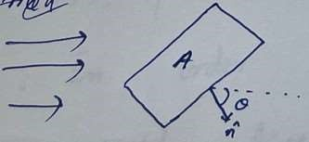
From the above three dependencies we can write:

Φ = V A cos θ = V⃗ · A⃗ = V⃗ · nˆ A
where nˆ , is the normal vector, perpendicular to the surface.
What if the surface is curved? Break the surface into small rectangular pieces, find V⃗ · nˆ dA for each piece, then add all the pieces together. This means we have to integrate for the whole surface.
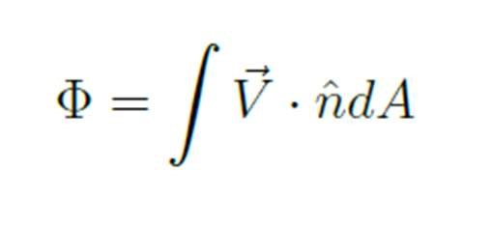

Flux of an Electric Field
similar to air flux, but now instead of air, it will be electric field lines passing through an area.
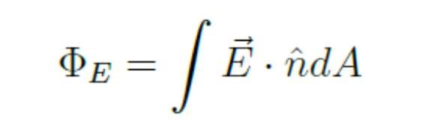

The total number of electric field lines that passes through a surface. If the surface is a closed surface, then the integration will be over a closed surface. This kind of closed surface is called Gaussian Surface. The integration will become.
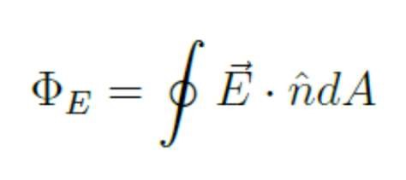

The electric flux through a Gaussian Surface is proportional to the net number of E-field lines passing through that surface.
Example: Calculate electric flux over a spherical shell centered on a point charge q.

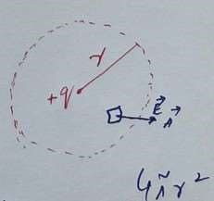
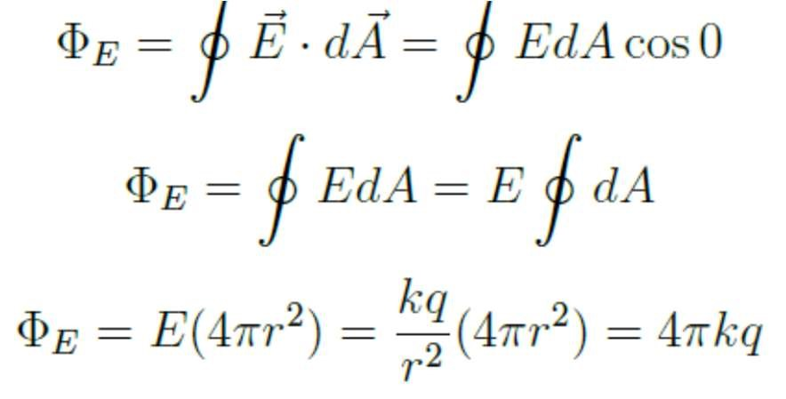
If q is not inside the gaussian surface, then the net flux through the surface would be zero. Additionally, we can see that the result is independent of r.

Example

Find the net flux through the cylinder, shown in the figure below.

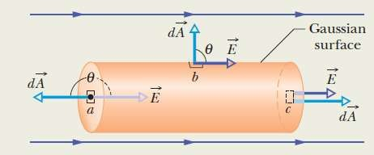
Figure 1: Figure adopted from HRW

