PHYSICS 2: HOMEWORK 2

- An electric dipole consists of charges +2e and -2e separated by 0.78 nm. It is in electric field of strength 3.4 x 10⁶ N/C. Calculate the magnitude of the torque on the dipole when the dipole moment is (a) parallel to, (b) perpendicular to, and (c) antiparallel to the electric filed.

- In the figure below, a buttery net is in a uniform electric field of magnitude E = 3.0 x 10⁻³ N/C. The rim of the net is a circle of radius a = 0.11 m, is aligned perpendicular to the field. There is no net electric charge on or near the netting. Find the electric flux through the netting.

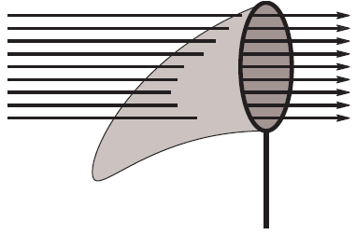
- Space vehicles traveling through Earth's radiation belts can intercept a significant number of electrons. The resulting charge buildup can damage electronic components and disrupt operations. Suppose a spherical metal satellite 1.3 meters in diameter accumulates 2.4 x 10⁻⁶ C of charge in one orbital revolution. (a) Find the resulting surface charge density. (b) Calculate the magnitude of the electric field just outside the surface of the satellite due to the surface charge.

- In the figure below, a small, nonconducting ball of mass m = 1.0 x 10⁻³ kg and charge q = 2.0 x10⁻⁸ C (distributed uniformly throughout its volume) hangs from an insulating thread that makes an angle θ = 30◦ with a vertical, uniformly charged nonconducting sheet (shown in cross section). Considering the gravitational force on the ball and assuming the sheet extends far vertically and into and out of the page, calculate the surface charge density (charge per area) σ of the sheet.

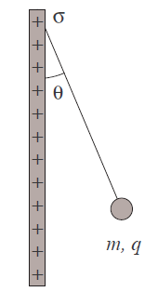

- Charge q is uniformly distributed over a sphere of radius R. Find the electric field at r > R.

- A point charge causes an electric flux of -750 N.m²/C to pass through a spherical Gaussian surface of 10.0 cm radius centered on the charge. (a) If the radius of the Gaussian surface were doubled, how much flux would pass through the surface? (b) What is the value of the point charge?

