Physics 2 Homework 3

- In the figure below a section of a conducting rod of radius R₁ = 1.30 mm and length L = 11.00 m inside a thin-walled coaxial conducting cylindrical shell of radius R₂ = 10.0R₁ and the (same) length L. The net charge on the rod is Q₁ = 3.40 x 10⁻¹² C; that on the shell is Q₂ = -2.0Q₁. What are the (a) magnitude E and (b) direction (radially inward or outward) of the electric field at radial distance r = 2.0R₁? What are (c) E and (d) the direction at r = 5.0R₁ ? What is the charge on the (e) interior and (f) exterior surface of the shell?
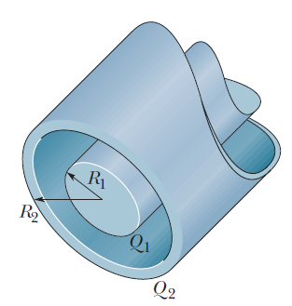

- In the figure below, the solid lines represent electric field lines and the dashed lines represent equipotential lines. When an electron moves from point A to point B along the electric field line, the electric field does 3.94 × 10⁻¹⁹ J of work on it. What are the electric potential differences (a) V_{B} – V_{A}, (b) V_{C} – V_{A}, and (c) V_{C} – V_{B}?
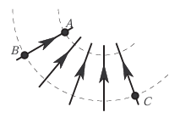
- Two large parallel conducting plates are 0.12 meters apart and have charges of equal magnitude and opposite sign on their facing surfaces. An electrostatic force of 3.9 × 10⁻¹⁵ N acts on an electron placed anywhere between the two plates. (a) Find the electric field at the position of the electron. (b) What is the potential difference between the two plates?

- Two electrons are held at fixed positions separated by 0.020 m. A third electron is shot from infinity and stops midway between the two. What is its initial speed?

- Two particles of charges q₁ and q₂ are separated by distance d, as shown in the figure below. The net electric field due to the particles is zero at x = d/4. With V = 0 at infinity, locate (in terms of d) any point on the x-axis (other than infinity) at which the electric potential due to the two particles is zero.

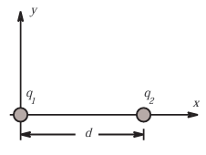

- In the figure above, particles of charges q₁ = +5e and q₂ = −15e are fixed in place with a separation of d = 0.240 m. With V = 0 at infinity, what are the finite (a) positive and (b) negative values of x at which the net electric potential on the x-axis is zero?

- How much work is required to set up the arrangement of charges shown in the figure below if q = 2.30×10⁻¹² C, a = 0.640 m, and the particles are initially far apart and at rest?

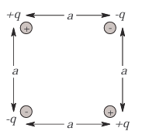

- A plastic disk of radius R = 0.640 m is charged on one side with a uniform surface charge density σ = 7.73×10⁻¹⁵ C/m², and then three quadrants of the disk are removed. The remaining quadrant is shown in the figure below. With V = 0 at infinity, what is the potential due to the remaining quadrant at point P, which is on the central axis of the original disk at distance D = 0.259 m from the original center?

- Two isolated, concentric, conducting spherical shells have radii R₁ = 0.500 m and R₂ = 1.00 m, uniform charges q₁ = +2.00 × 10⁻⁶ C and q₂ = +1.00 ×10⁻⁶ C, and negligible thicknesses. What is the magnitude of the electric field E at radial distances (a) r = 4.00 m, (b) r = 0.700 m, and (c) r = 0.200 m? With V = 0 at infinity, what is V at (d) r =4.00 m, (e) r = 1.00 m, (f) r = 0.700 m, (g) r = 0.500 m, (h) r = 0.200 m, and (i) r =0.000 m? (j) Sketch E(r) and V(r).

- In the figure below, what is the net electric potential at the origin due to the circular arc of charge Q₁ = 7.21 pC and the two particles of charges Q₂ = 4.0 Q1 and Q₃ = -2.0Q1? The arc’s center of curvature is at the origin and its radius is R = 2.0 m; the angle indicated is $θ= {20}^{o}$.

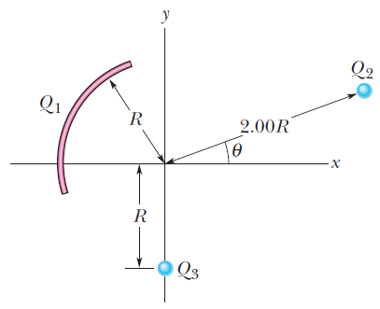

- The electric potential V in space between two flat parallel plates 1 and 2 is given (in volts) by V = 1500x² , where x (in meters) is the perpendicular distance from plate 1. At x =1.3 cm, (a) what is the magnitude of the electric field and (b) is the field directed toward or away from plate 1.

