PHYSICS 2: HOMEWORK 4
- You have two flat metal plates, each of area 1.00 m², with which to construct a parallel plate capacitor. (a) If the capacitance of the device is to be 1.00 F, what must be the separation between the plates? (b) Could this capacitor actually be constructed?

- A parallel-plate capacitor has circular plates of 0.0820 m radius and 1.30 × 10⁻³ m separation. (a) Calculate the capacitance. (b) What charge will appear on the plates if a potential difference of 120 volts is applied?

- Each of the uncharged capacitors in the figure below has a capacitance of 2.5 ×10⁻⁵ F. A potential difference of V = 4200 volts is established when the switch is closed. How many coulombs of charge passed through meter A as the capacitors charged?

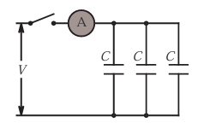

- In the figure below, two parallel-plate capacitors (with air between the plates) are connected to a battery. Capacitor C₁ has a plate area of 1.5×10⁻⁴ m² and an electric field between its plates of magnitude 2000 V/m. Capacitor C₂ has a plate area of 7.0×10⁻⁵ m² and an electric field of magnitude 1500 V/m. What is the total charge on the two capacitors?
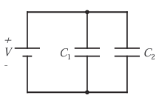
- In figure below, find the equivalent capacitance of the combination. Assume C₁ is 10.0 µF, C₂ is 5.0 µF and C₃ is 4 µF. What is the charge on C₃? The battery voltage is 10 volts.

