PHYSICS - 2: HOMEWORK 6
Chapter 28 (Magnetic Fields)

- An electron with a kinetic energy of 22.5 eV moves into a region of uniform magnetic field of magnitude 4.55 x 10⁻⁴ T. The angle between the directions of magnetic field $\vec{B}$ and the electron’s velocity is 65.5°. What is the pitch of the helical path taken by the electron?

- An ion source is producing ${}_{3}^{6}{Li}$ ,ions which have charge +e and mass 9.99 × 10⁻²⁷ kg. The ions are accelerated by a potential difference of 10,000 volts and pass horizontally into a region in which there is a uniform vertical magnetic field of magnitude B = 1.2 T. Calculate the strength of the smallest electric field, to be set up over the same region, that will allow the ${}_{3}^{6}{Li}$ ions to pass through undeflected.

- A strip of copper 1.5 × 10⁻⁴ m thick and 4.5 × 10⁻³ m wide is placed in a uniform magnetic field B of magnitude 0.65 T with B perpendicular to the strip. A current i = 23 A is then sent through the strip such that a Hall potential difference V appears across the width of the strip. Calculate V. The number of charge carriers per unit volume for copper is 8.47 × 10²⁸ m⁻³.

- A metal strip 0.0650 m long, 8.50×10⁻³ m wide and 7.60×10⁻⁴ m thick moves with constant velocity v through a uniform magnetic field B = 1.20×10⁻³ T directed perpendicular to the strip, as shown in the figure below. A potential difference of 3.90×10⁻⁶ volts is measured between points a and b across the strip. Calculate the speed v.

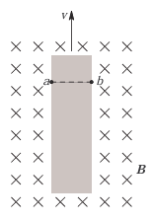
- What uniform magnetic field, applied perpendicular to a beam of electrons moving at 1.30 ×10⁶ m/s, is required to make the electrons travel in a circular arc of radius 0.350 m?

- In the figure below, a charged particle moves into a region of uniform magnetic field B, goes through a half-circle, and then exits that region. The particle is either a proton or an electron (you must figure out which). It spends 1.30×10⁻⁷ s in the region. (a) What is the magnitude of B? (b) If the particle is sent back through the magnetic field (along the same initial path) but with 2.00 times its previous kinetic energy, how much time does it spend in the field during this trip?

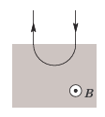

- A metal rod of mass 0.013 kg and length L = 0.620 m is suspended by a pair of flexible conducting leads in a uniform magnetic field B = 0.440 T. The leads are connected to metal blocks anchored into the wall, and the metal blocks are connected to a battery that provides sufficient current to the metal rod to remove the tension in the supporting leads. What are the (a) magnitude and (b) direction (left or right) of the current flowing in the metal rod?
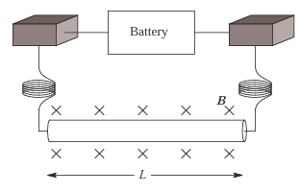
- The figure below shows an overhead view of a metal wire of mass m = 2.41 × 10⁻⁵ kg which can slide with negligible friction on two horizontal parallel metal rails separated by distance d = 0.0256 m. The track lies in a vertical uniform magnetic field B = 0.0563 T. At time t = 0, device G is connected to the rails producing a constant current i = 9.13 ×10⁻³ A in the wire and the rails (even as the wire moves). At t = 0.0611 s, what are the wire’s (a) speed and (b) direction of motion (left or right)?

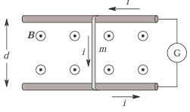
- The figure below shows a rectangular 20-turn coil of wire, of dimensions 0.10 m by 0.050 m. It carries a current of 0.10 A and is hinged along one side. It is mounted in the x−y plane, at an angle of θ = 30◦ to the direction of a uniform magnetic field B = 0.50 T. In unit-vector notation, what is the torque acting on the coil about the hinge line (the y-axis)?

