PHYSICS - 2: HOMEWORK 7
Chapter 27 (Circuits)

- A 120 volt potential difference is applied to a space heater whose resistance is 14Ω when hot. (a) At what rate is electrical energy transferred to thermal energy? (b) What is the cost for 5.0 h at US$0.05/kW · h?

- A 100 W light bulb is plugged into a standard 120 volt outlet. (a) How much does it cost per 31-day month to leave the light turned on continuously? Assume electrical energy costs US$0.06/kW · h. (b) What is the resistance of the bulb? (c) What is the current in the bulb?

- A copper wire of cross-sectional area 2.00×10⁻⁶ m² and length 4.00 m has a current of 2.00 A uniformly distributed across the area. (a) What is the magnitude of the electric field along the wire? (b) How much electrical energy is transferred to thermal energy in 30 minutes?

- In the figure below, the ideal batteries have emfs (Ɛ) 12.0 volts , 6.0 volts and the resistors have resistances R1 = 4.0Ω and R2 = 8.0Ω. What are (a) the current, the dissipation rate (Power) in (b) resistor 1 and (c) resistor 2 (emfs are just the voltage of the batteries).

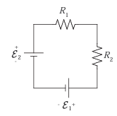
- The figure below shows a circuit whose elements have the following values:
Ɛ₁ = 3.0 V, Ɛ₂ = 6.0 V
R₁ = 2.0 Ω, R₂ = 2.0 Ω
Find the magnitude and direction of the current in each of the three branches.

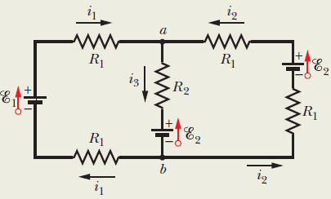

- Some capacitors are “leaky:” after they are charged, the charge on one plate will “leak” over to the other plate slowly discharging the capacitor. We can treat a leaky capacitor as though it was an ideal capacitor in parallel with a resistor, which acts like the “leak” in the capacitor. The potential difference between the plates of a leaky 2.0 × 10⁻⁶ F capacitor drops to one-fourth its initial value in 2.0 seconds. What is the equivalent resistance between the capacitor plates?

- What multiple of the time constant (RC) gives the time taken by an initially uncharged capacitor in an RC series circuit to be charged by 99.0% of its final charge?

- A capacitor with initial charge q₀ is discharged through a resistor. What multiple of the time constant (RC) gives the time the capacitor takes to lose (a) the first one-third of its charge and (b) two-thirds of its charge?

