True/False
- An object at rest will stay at rest unless acted upon by a non-zero net external force
  - True b. False
- Every force has an equal and opposite force
  - True b. False
- Units do NOT play a role in working with Physics problems
  - True b. False
- Velocity and speed are the same thing
  - True b. False
- The slope of the line on the velocity vs time graph yields the acceleration
  - True b. False
- The area under the line on an acceleration vs time graph yields the position
  - True b. False
- If the line on a position vs time graph is curved, there is acceleration in the system
  - True b. False
- The sum of the forces acting on an object will be equal to the mass of the object multiplied by the acceleration the object is experiencing
  - True b. False

Problems
- Convert 8 cm/s to
  - meters per hour
a) 200 m/hr b) 0.3 m/hr c) 288 m/hr d) 35 m/hr
  - feet per minute given that 1 ft = 0.305 m.
a) 15.7 ft/min b) 0.15 ft/min c) 200 ft/min d) 70.2 ft/min
- Given the Velocity vs Time graph below, find the:
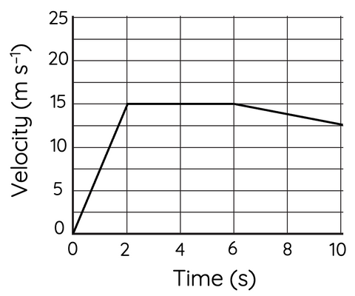
  - acceleration from t=6 to t=10
a) -2.3 m/s² b) 1.6 m/s² c) -1.6 m/s² d) 2.3 m/s²
  - total displacement of the particle at 6 seconds
a) 67.5 m b) 80.0 m c) 40.5 m d) 64.0 m
- A 40 N force is applied to a 8 kg box across a surface with a coefficient of friction μ=0.2 and an initial velocity of 1 m/s.
  - What acceleration is the box experiencing?
a) 8 m/s² b) 2.5 m/s² c) 3 m/s² d) 1.2 m/s²
  - How much time will it take the box to travel 20 meters?
a) 3.33 s b) 4.23 s c) 1.34 s d) -4.00 s
  - What velocity will the box be experiencing at t = 5?
a) 15 m/s b) 19 m/s c) -12 m/s d) 16 m/s

