- Convert 30 millimeters/minute to feet/second given that 1 foot = 0.305 meter
  - 2.00 ft/s
  - 0.002 ft/s
  - 7.00 ft/s
  - 0.007 ft/s
- Which position versus time graph below shows acceleration?
  - 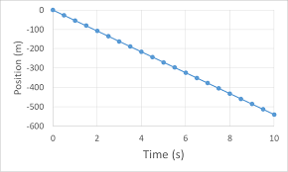
  - 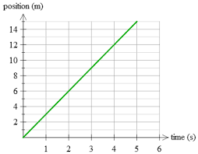
  - 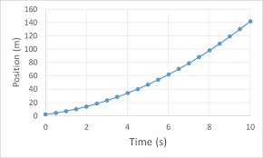
3-5. A particle is given a displacement function r(t) = -3t²i – 5j + 4t⁴k meters, answer the following questions
- What is the location of the particle after 4 seconds in the x, y, and z directions?
  - (-24, -20, 1024)
  - (48, 34, -1000)
  - (-12, -5, 16)
  - (-48, -5, 1024)
- What is the velocity equation for the particle given that it starts from rest?
  - V(t) = -6ti + 0j + 16t³k
  - V(t) = -3ti – 5j + 16t³k
  - V(t) = 6ti – 5j + 12t³k
  - V(t) = 0i – 0j + 0k
- What is the magnitude of the acceleration of the particle at 0.3 seconds?
  - -31.1 m/s²
  - 20.4 m/s²
  - 15.2 m/s²
  - 13.1 m/s²
6-8. A 7 kg box undergoes a force given the equation F(t) = 7ti + -2t²j N, answer the following questions
- What is the acceleration function for the box?
  - a(t) = 4i + -2/7tj
  - a(t) = 7i + 7j
  - a(t) = 1ti – 2/7t²j
  - a(t) = -5i + 7/2t²j
- Given that the box starts with a velocity of 2 m/s in the y direction and from rest in the x, what is its velocity function?
  - V(t) = (1/2t² + 2)i – 2/21t³j
  - V(t) = (1/2t²)i – (2/21t³+2)j
  - V(t) = (7t + 2)i – 2/21t³j
  - V(t) = (7t)i – (2/21t³ +2)j
- What is the magnitude of the displacement of the box after 2 seconds?
  - 4.58 m
  - -3.46 m
  - 10.54 m
  - 2.34 m
9-11. A plane is dropping supplies to a remote village. It is flying with a horizontal velocity of 23 m/s and a height of 300 meters. Given that the supplies drop by free fall with no vertical initial speed, answer the following
- How long will it take the items to fall to the ground?
  - 43 seconds
  - 9 seconds
  - 30 seconds
  - 13 seconds
- How far away in the x direction should the plane release the package?
  - 900 meters
  - 690 meters
  - 230 meters
  - 540 meters
- What is the velocity in the x and y directions for the package after 23 seconds?
  - (-12, 300) m/s
  - (23, -10) m/s
  - (12, 10) m/s
  - (23, -300) m/s
12-13. m1 is on a surface with a coefficient of friction equal to 0.1 and a mass of 2 kg. Using this information, answer the following questions

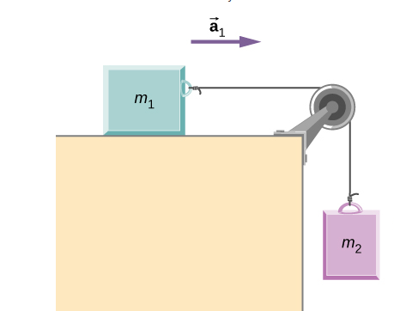
- If m1 is accelerating at 3 m/s², what is the mass of m2?
  - 4 kg
  - 1.14 kg
  - 3.4 kg
  - 0.24 kg
- If it started from rest, what is the velocity of m2 after 0.5 seconds?
  - 1.5 m/s
  - 2 m/s
  - 0.3 m/s
  - 2.5 m/s
- A bicyclist travels along trails in the woods. They go 23 meters at 45 degrees North of East then 45 meters 30 degrees West of North before turning and going 34 meters at 60 degrees South of East. What is the magnitude of their total displacement?
  - 12 m
  - 52 m
  - 45 m
  - 28 m

