FRE 102 : Rédaction
BATY
Block 6, 2018

In French 102, you will continue to refine your writing skills in short, simple, elegant French.

You will write a 3-4 pp composition for this course, which will be divided into 3 different parts (see Programme du cours for deadlines). Each part will be submitted for a preliminary (though unofficial) grade and feedback. At the end of the course, you will revise, combine and resubmit the three parts as one final composition. This final composition should have a formal title and will be graded.

As a general rule, never write first in English, then translate into French; this will lead to really bad French. Avoid looking up lots of words in the dictionary. I prefer that you recycle the vocabulary that you are studying as much as possible in your written work.

Writing assignments must be typed with accents included. They may be submitted to me in class or via Moodle, but they must be submitted by 3 p.m. on the day they are due.

*Please re-read the section of your syllabus about academic Honesty before you begin work on this assignment! Use of Google Translate is not acceptable for this work.

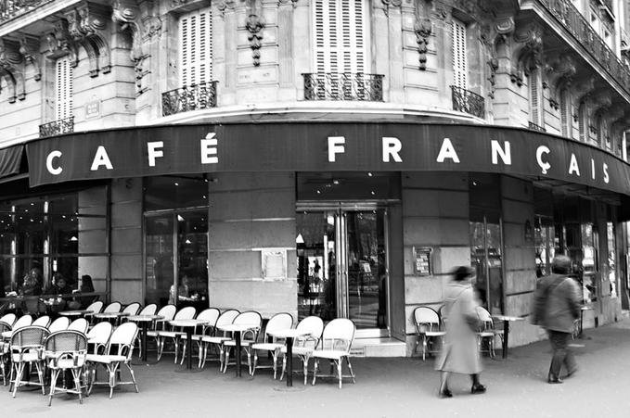

TOPIC :
You are a beginning student of French who also happens to be an aspiring novelist who spends lots of hours writing in cafés. You decide that your first mystery novel will begin with an everyday scene in a café. In order to expand your creative horizons, you have decided to write in French, using a minimalist style.

Your café scene will be divided into 3 parts, each 2-3 paragraphs in length. Include one photograph or image for each part; these photographs may be “artsy” or conventional. They may be your own photos or pictures you find on the internet; they should be no larger than the photo on this page.

Part 1: Description générale du café
½ -1 page
Use the present tense. Specify the café’s name and provide a photo of the interior of the café. This café does not need to be French; it could be a local café with which you are more familiar or a completely imaginary café in the location of your choice. Use as many adjectives as you can to describe it and describe its location in relation to other businesses in the neighborhood. What kinds of food and drink are served there? (Review the use of the partitive for this section. ex: “On sert de la pizza….”) Describe a few of the regular clients. What are their names? What do they usually wear? Tell us something about their lives; this could be about their families/their hobbies/their professions, etc. What do they like to do and what do they typically order at the café?
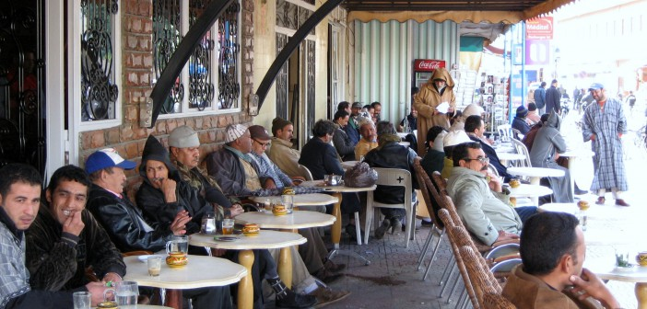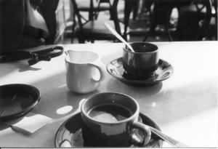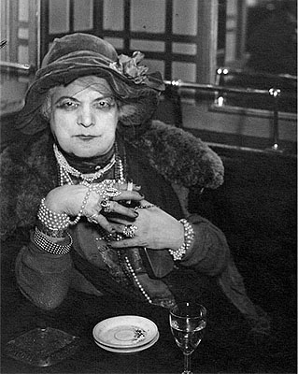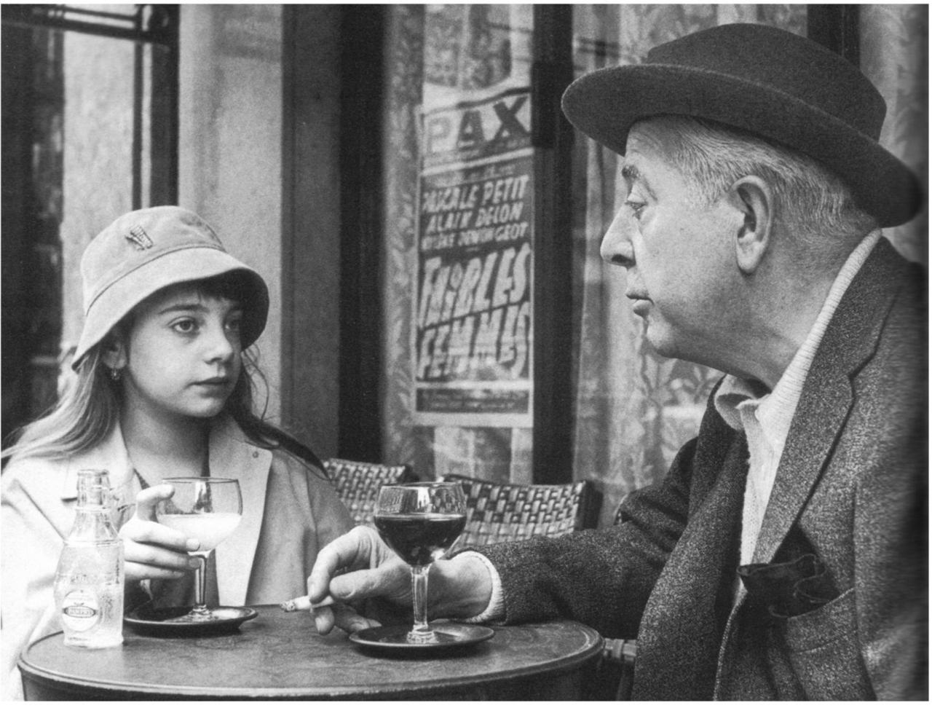

Part 2: Description de la scène: l’arrière-fond (background)

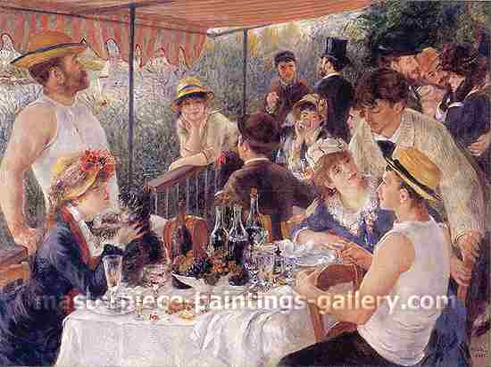

In this section, you will focus on a specific time on a specific date in the café. Begin by stating the time and date (Ex: C’etait lundi, le 30 octobre, 2005.) Use the imparfait to set the background scene for your story. Who was in the café that day? Describe their physical appearance, age and clothing. What were they eating and drinking? What were they doing at the time when your story begins?

½ -1 page

Part 3: Description de l’action: Qu’est-ce qui se passe?
Narrate what actually happened in the café that day; this will serve as the beginning of your novel’s plot. Use the passé composé to put the actions in chronological order. Use transition words to advance your narrative. Once you have a list of chronological actions, add descriptive details using the imparfait to flesh out your story. Review the differences between use of the imparfait and the p.c. before working on this section.

½ -1 page

Part 4: Final version

Revise your three drafts and pull them all together into one polished essay, adding transitions where necessary. Add a formal title to your “novel.” Turn in a printed version on the final day of class.
3-4 pp, ½ -1 page

