Sir Isaac Newton
http://www3.gettysburg.edu/~tshannon/hist106web/site6/sir_isaac_newton.htm
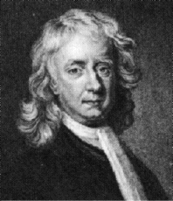 | 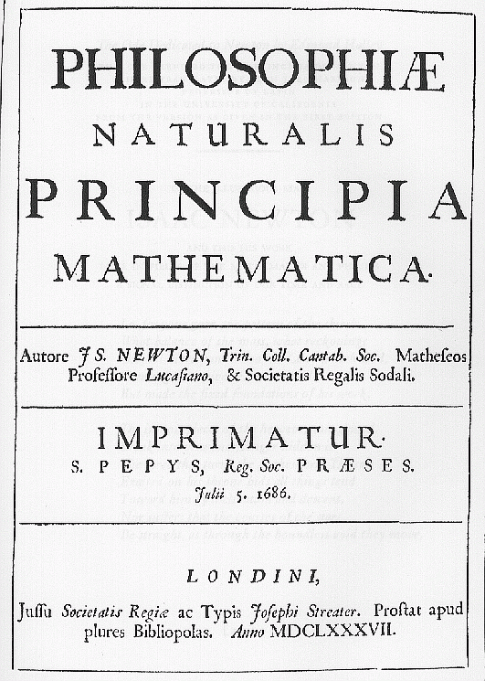
Sir Isaac Newton was an English scientist, astronomer and mathematician. Newton believed that the universe was like a massive clock built by a creating god and set into motion. For Newton the universe was a vast machine composed of interacting objects and could therefore be understood as a machine. Newton’s entire view of the universe was based on the concept of inertia. Inertia states that every object remains at rest until moved by another object and every object in motion stays in motion until stopped by another object. Newton’s mechanistic view of the universe was later applied to rationally understanding economics, history, politics and ethics. Newton’s many discoveries included how the universe is held together through his theory of gravitation, secrets of light and color and calculus.
Newton’s discoveries on the laws of motion and the sources of gravitation were published in The Mathematical Principles of Natural Philosophy (1687). Newton realized that the force that pulls an object to earth is the same force that keeps the moon in its orbit. He discovered that the force of universal gravitation makes every pair of bodies in the universe attract each other. This force depends on the distance between the bodies being attracted and the amount of matter in the bodies as well as the distance between the bodies. Newton’s Principia Mathematica was considered the greatest contribution to the history of science.
Newton also made significant discoveries in optics. Newton was able to lay the foundation for the science of spectrum analysis and explain why bodies appeared to be colored. This science allows us to determine the chemical composition, temperature and speed of either a star or simply an object heated in the laboratory. Due to Newton’s concept of the mechanical universe a massive amount of empirical knowledge about the physical world erupted. As the amount of observations grew both knowledge and the effort to arrange knowledge increased. Sir Isaac Newton was one of the first people to convert knowledge into a traditional system during the eighteenth century’s scientific revolution.

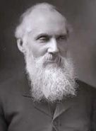 Sir William Thomson, Lord Kelvin (1824 - 1907)
http://www.bbc.co.uk/history/historic_figures/kelvin_lord.shtml
Kelvin was a Scottish mathematician and physicist who developed the Kelvin scale of temperature measurement.
William Thomson was born on 26 June 1824 in Belfast. He was taught by his father, a professor of mathematics. In 1832, the family moved to Glasgow where Thomson attended university from the age of 10, subsequently studying at Cambridge and Paris universities. In 1846 he became professor of natural philosophy in Glasgow, a post he would hold for more than 50 years.
In Glasgow, Thomson created the first physics laboratory in Britain. He was a pioneer in many different fields, particularly electromagnetism and thermodynamics. Together with Faraday, he was responsible for the introduction of the concept of an electromagnetic field. In thermodynamics, Thomson assimilated and developed the work of the pioneers of the subject, Nicolas Carnot and James Joule. One of the most important results of his work was his idea of an absolute zero of temperature - the scale based on this is named after him.
Throughout his work Thomson's overriding goal was the practical utilisation of science. He achieved fame through his work on submarine telegraphy, a major practical problem of the day. Kelvin was employed as a scientific adviser in the laying of the Atlantic telegraph cables in 1857-1858 and 1865-1866, for which he was knighted in 1866. His interest in marine issues also inspired him to develop a mariners' compass and invent a tide machine and depth-measuring equipment. He invented many electrical instruments and his house in Glasgow was the first to be lit by electric light.
Thomson was raised to the peerage with the title of Baron Kelvin of Largs in 1892 (the Kelvin was a small river that flowed near Glasgow University) and was president of the Royal Society from 1890 to 1895. He died on 17 December 1907 in Ayrshire, Scotland and was buried in Westminster Abbey.

Amalie Emmy Noether  https://en.wikipedia.org/wiki/Noether%27s_theorem  https://en.wikipedia.org/wiki/Emmy_Noether  (German, 23 March 1882 – 14 April 1935) was a German mathematician known for her landmark contributions to abstract algebra and theoretical physics.  She was described by Pavel Alexandrov, Albert Einstein, Jean Dieudonné, Hermann Weyl, and Norbert Wiener as the most important woman in the history of mathematicsAs one of the leading mathematicians of her time, she developed the theories of rings, fields, and algebras. In physics, Noether's theorem explains the connection between symmetry and conservation laws. | 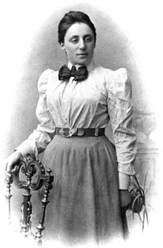
Noether's (first) theorem states that every differentiable symmetry of the action of a physical system has a corresponding conservation law. The theorem was proven by mathematician Emmy Noether in 1915 and published in 1918. The action of a physical system is the integral over time of a Lagrangian function (which may or may not be an integral over space of a Lagrangian density function), from which the system's behavior can be determined by the principle of least action.
All fine technical points aside, Noether's theorem can be stated informally
If a system has a continuous symmetry property, then there are corresponding quantities whose values are conserved in time.[3]
A more sophisticated version of the theorem involving fields states that:
To every differentiable symmetry generated by local actions, there corresponds a conserved current.
The word "symmetry" in the above statement refers more precisely to the covariance of the form that a physical law takes with respect to a one-dimensional Lie group of transformations satisfying certain technical criteria. The conservation law of a physical quantity is usually expressed as a continuity equation.
The formal proof of the theorem utilizes the condition of invariance to derive an expression for a current associated with a conserved physical quantity. In modern (since ca. 1980[4]) terminology, the conserved quantity is called the Noether charge, while the flow carrying that charge is called the Noether current. The Noether current is defined up to a solenoidal (divergenceless) vector field.

