DAY7 Ben, Bram, Kaiyu, Qingyuan, Yuzhe
- SGDClassifier is a linear classifier which implements regularized linear models with stochastic gradient descent (SGD) learning.
- Precision: accuracy of the positive predictions. (precision = TP/(TP+FP))
- Recall: also called sensitivity or true positive rate, this is the ratio of positive instances that are correctly detected by the classifier. (recall = TP/(TP+FN))
- 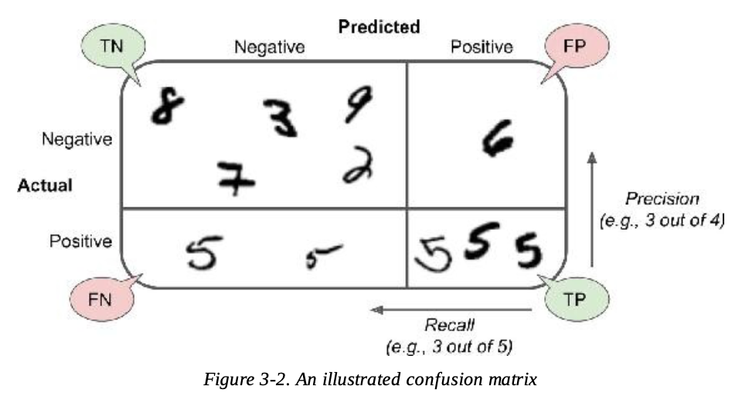

- Precision/recall tradeoff
- 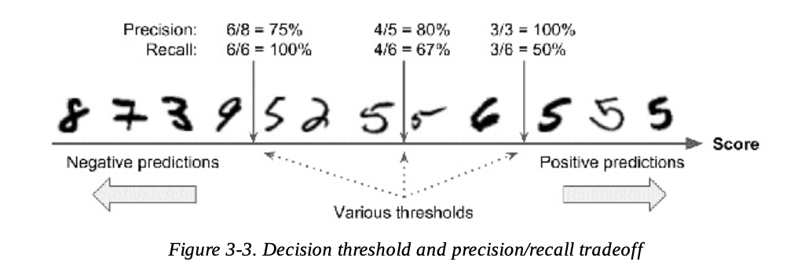
- How SGDClassifier makes its classification decisions. It computes a score based on a decision function, and if that score is greater than a threshold, it assigns the instance to the positive class, or else it assigns it to the negative class.
- The decision threshold is positioned at the central arrow: you will find 4 true positive (actual 5s) on the right of that threshold, and one false positive (actually a 6).
Precision = 80%
But out of 6 actual 5s, the classifier only detects 4.
Recall = 67%
- Raise the threshold, move it to the right.
The false positive (the 6) becomes a true negative.
Precision = 100%
Bit one true positive becomes a false negative.
Recall = 50%
……

- You can call decision_function() method, which returns a score for each instance, and then make predictions based on those scores using any threshold you want:
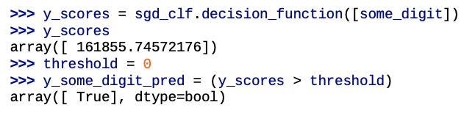

- How can you decide which threshold to use?
- Get the scores of all instances in the training set using the cross_val_predict() function again:
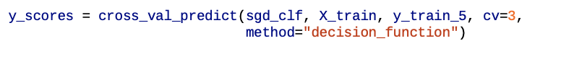
- Compute precision and recall for all possible thresholds using the precision_recall_curve() function:
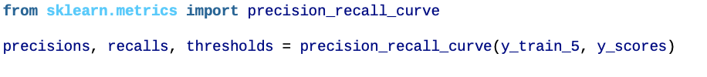
- Plot precision and recall as functions of the threshold value using Matplotlib:
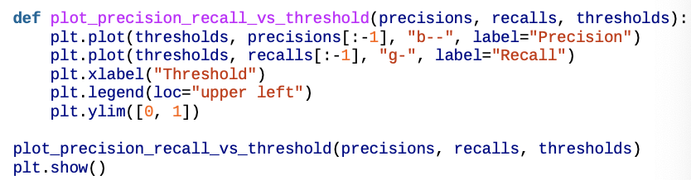

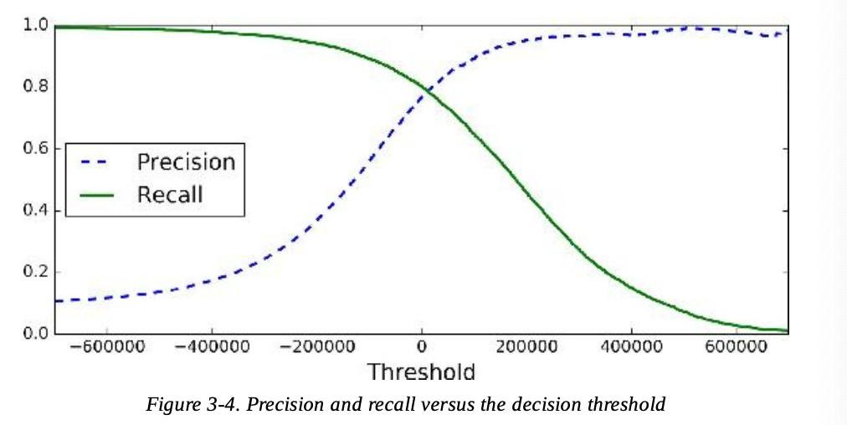
Other methods:
Plot precision directly against recall:
