s

Lesson 04
CSC357 Machine Learning
21 January 2020
Stochastic Gradient Descent

Instructor: Leon Tabak
Authors: Alex Heisdorffer, Chenxi Liu, Yudong Zhang, Linda Wang

Gradient Decent & Stochastic Gradient Decent
Gradient Decent:
Gradient descent is an optimization algorithm used to minimize some function by iteratively moving in the direction of steepest descent as defined by the negative of the gradient. Dependent variable is error.
Linear Regression
Loss Function (In the linear regression): Sum of the residuals = (Observed Height – Predicted Height) ^2
- Take derivatives of the loss function respect to intercept and slope
- Plug the initial guess of intercept and slope, get new slope2 at a particular point
- Step Size = slope2 * learning rate
- New Intercept = Old Intercept – Step Size
New Slop = Old Slope – Step Size
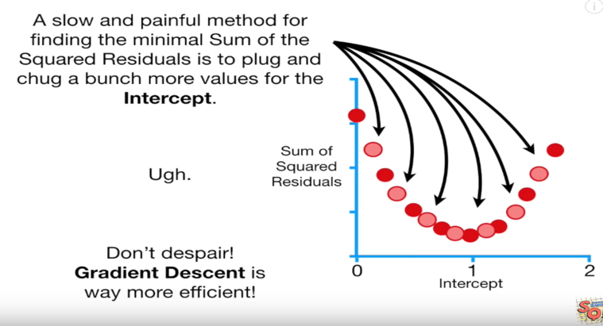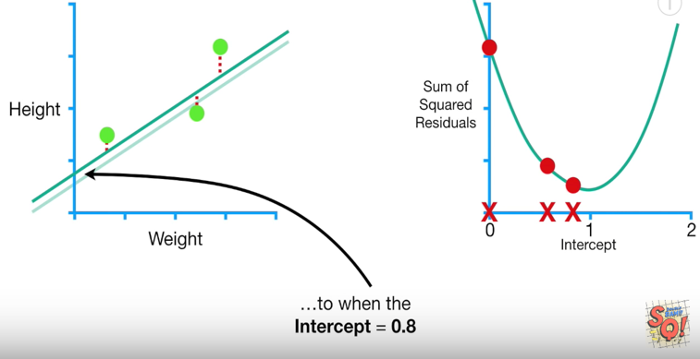
Gradient Decent stops when the step size is very close to 0.
Every time, we will have better result: We can have new intercept and new slope.

Stochastic Gradient Decent:
In both gradient descent (GD) and stochastic gradient descent (SGD), you update a set of parameters in an iterative manner to minimize an error function.

What happen if we have complicated model?
Advantage:
- SGD would randomly pick on sample for each step.
- Just use that one sample to calculate the derivatives.
- In this example, SGD reduced the number of terms computed by a factor of 3.

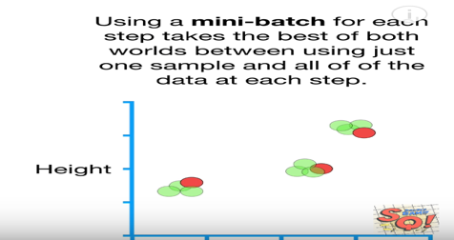
Stochastic Gradient Decent is especially useful when there are redundancies in the data.
- SGD normally means using one sample per step.
- It is more common to select a small subset of
data, or Mini-Batch.
- Mini-Batch is more stable and faster.

Reference:
https://ml-cheatsheet.readthedocs.io/en/latest/gradient_descent.html
https://towardsdatascience.com/stochastic-gradient-descent-clearly-explained-53d239905d31
https://developers.google.com/machine-learning/crash-course/reducing-loss/stochastic-gradient-descent

