Lesson 05
CSC357 Machine Learning
22 January 2020
Natural Language Processing

Instructor: Leon Tabak
Authors: Chenxi Liu, Yudong Zhang, Linda Wang, Alex Heisdorffer

What is the NLP?
Natural language processing (NLP) is a branch of artificial intelligence that helps computers understand, interpret and manipulate human language.
NLP draws from many disciplines, including computer science and computational linguistics, in its pursuit to fill the gap between human communication and computer understanding.

Why is important?
Natural language processing helps computers communicate with humans in their own language and scales other language-related tasks. For example, NLP makes it possible for computers to read text, hear speech, interpret it, measure sentiment and determine which parts are important.

NLP in today’s world

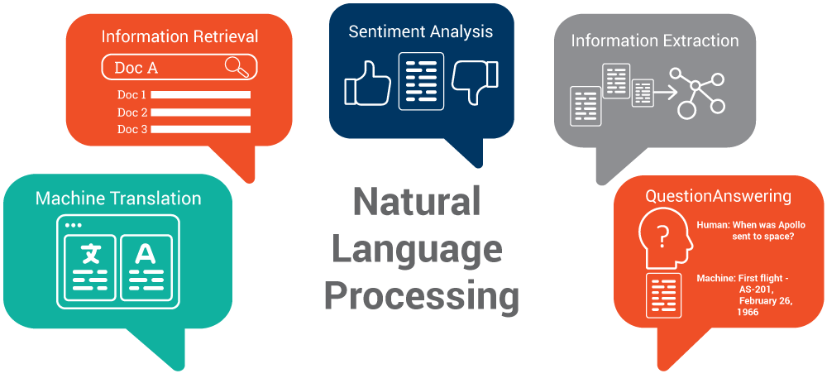
  - Google translation is one of the applications machine translation
  - Question and Answering, which is making Dialog systems answering
human questions automatically.
  - AI robot- Sophia can speak English and Chinese
  - Automatic summarization

Questions?
- What do you think about NLP in the future?
- What does NLP stand for?

References:
NLP Explanation: https://www.sas.com/en_us/insights/analytics/what-is-natural-language-processing-nlp.html
NLP about Sophia: https://www.boostlabs.com/natural-language-processing-for-customer-engagement/
Funny video about Sophia: https://www.youtube.com/watch?v=VQ3KOMqkUCE

