Lesson 06
CSC357 Machine Learning
23 January 2020
Activation Function

Instructor: Leon Tabak
Authors: Chenxi Liu, Yudong Zhang, Linda Wang, Alex Heisdorffer

- What is activation function?
Explanations: It’s just a thing function that you use to get the output of node. It is also known as transfer function.
Illustrations:
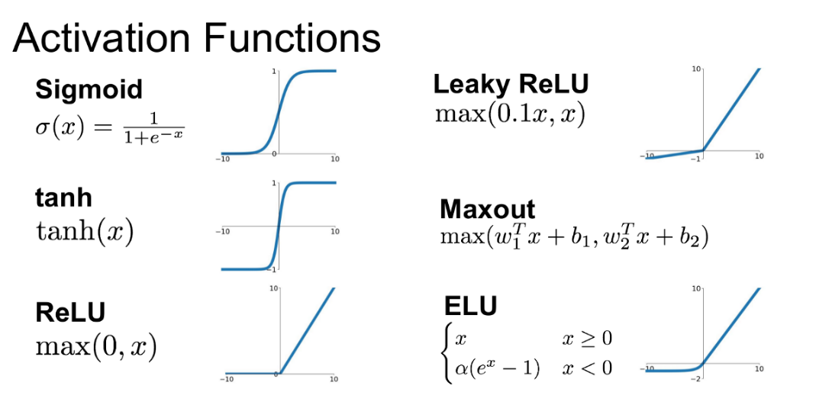

- What is the purpose of activation function?
Activation function decides whether a neuron should be activated or not by calculating weighted sum and further adding bias with it. The purpose of the activation function is to introduce non-linearity into the output of a neuron.
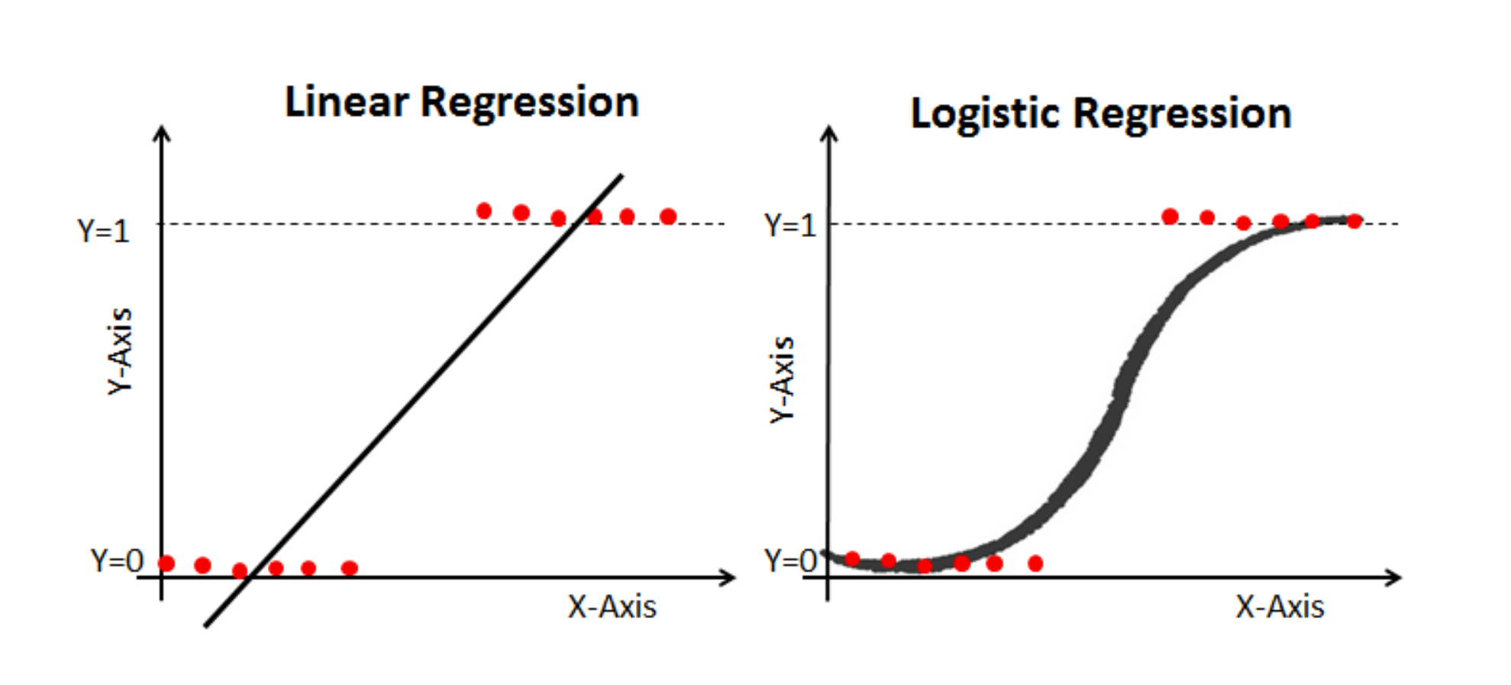
- Questions?
  - How many activation functions I mentioned above?
  - Which activation function does logistic regressor use?

- References:
Activation Function in Neural Network: https://medium.com/the-theory-of-everything/understanding-activation-functions-in-neural-networks-9491262884e0
Introduction of Activation Function: https://towardsdatascience.com/activation-functions-neural-networks-1cbd9f8d91d6
Understand logistic regression: https://www.datacamp.com/community/tutorials/understanding-logistic-regression-python

