Lesson 00
CSC357 Machine Learning
14 January 2020
Numpy Tutorial

Instructor: Leon Tabak
Authors: Alex Heisdorffer, Chenxi Liu, Yudong Zhang, Linda Wang

Question List:
- What is the use of numpy? Why do we need it?Why do programmers use numpy to create arrays instead of using lists?
- Does shape of array really matter when we doing matrix operations such as: multiplication or addition.
- What is broadcasting?
array1 = numpy.array([[1,2,3], [4,5,6]])
array2 = numpy.array([7,8,9,10])
array3 = array1 + array2
Did the interpreter identify an error?
- How to confirm the dimension of an array? How to create a N-dimensions array?
What the value of array1.ndim, array1.shape, array1.size? (array1 is the above example)
- What is the output you expect to see when running following code?
array4 = numpy.array([ [1,1,1], [2,2,2] ])
array5 = numpy.array([ [1,10], [1,10], [1,10] ])
print( array4.dot(array5) )
Notes of understanding matrix multiplication: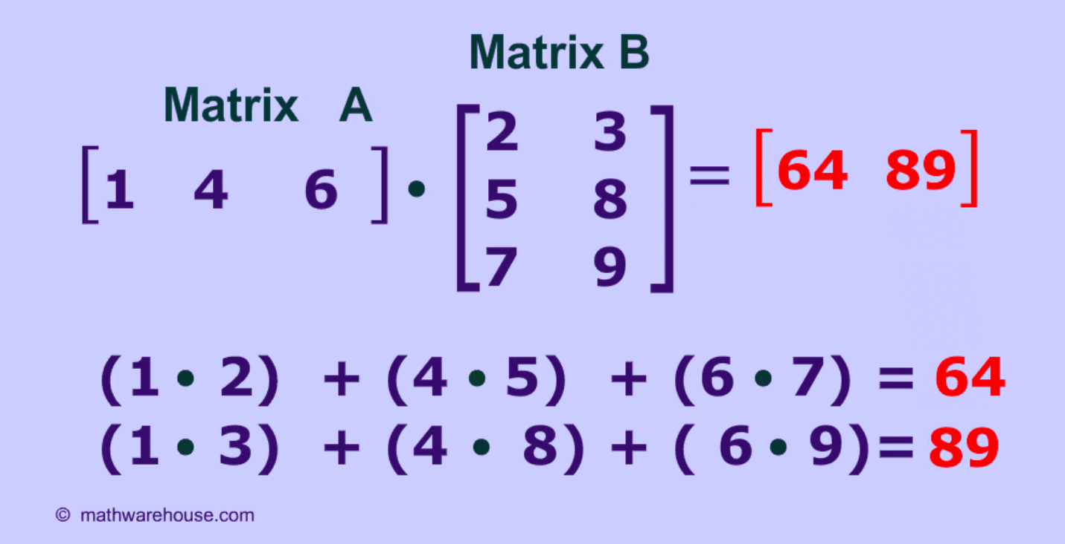
References:
- https://www.mathwarehouse.com/algebra/matrix/multiply-matrix.php
- https://guides.github.com/pdfs/markdown-cheatsheet-online.pdf
- http://cs231n.github.io/python-numpy-tutorial/
- https://docs.scipy.org/doc/numpy/reference/
- https://docs.scipy.org/doc/numpy/reference/arrays.html

