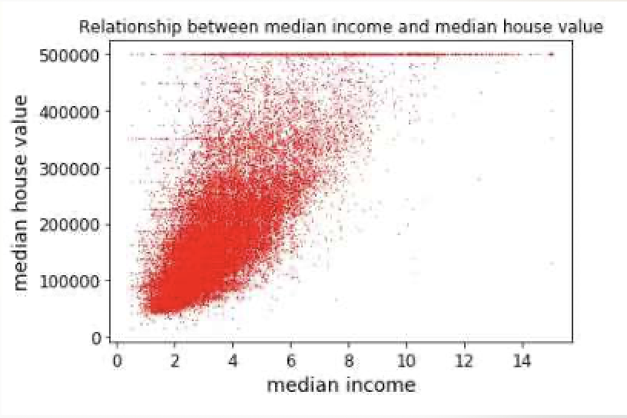
Visualizing the Data:
Visualizing the data is a very important step after we get the dataset,
before training the data, we need to have a general understanding of our dataset.
Scatter plots show how much one variable is affected by another.
“Matplotlib” can help us to draw scatter plot.
Examples 1:
- Import the library
import matplotlib.pyplot as plt

- Drawing scatter plot between two variables, and size is 0.1, color is red
plt.scatter(housing[“median_income”], housing["median_housing_value”],s=0.1, color=”red”)

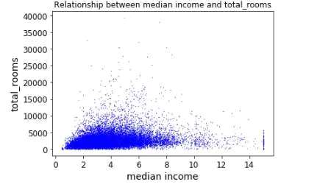
- Add a title and XY labels
plt.title(“relationship between median_income and median_housing_value”)
plt.xlabel(“median income”)
plt.ylabel(“median housing value”)

- Change some parameters
plt.scatter(housing[“median_income”], housing["total_rooms”],s=0.1, color=”blue”)
plt.title(“relationship between median income and total_rooms”)
plt.xlabel(“median income”)
plt.ylabel(“total_rooms”)

:

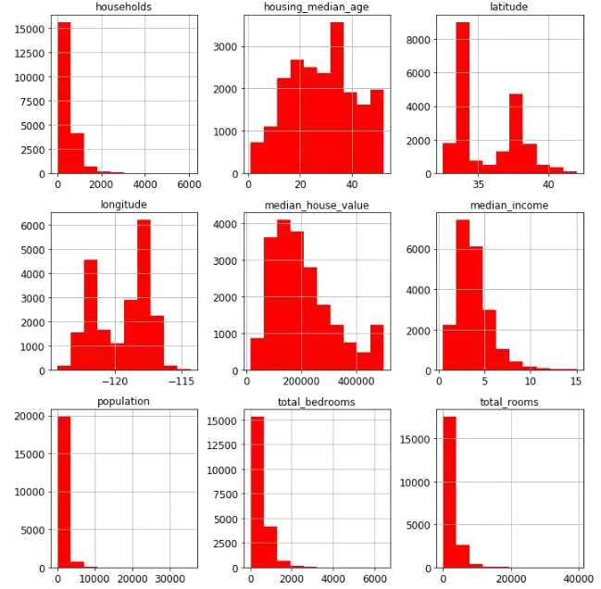
Histograms are used to graphically summarize and display the distribution of a process data set. “Matplotlib” can help us to draw histograms.
Example 2:
- Import the library
Import matplotlib.pyplot as plt

- Drawing histogram for all 9 variables
housing.hist(bins=10, figsize=(10,10), color = (“red”))

More bins means the given range is divided to more parts.
Figure size, first parameter represents length,
second parameter represents width.

Change some parameters
housing[“latitude”].hist(bins = 10, figsize(10,10),color=(“red”)). housing[“latitude”].hist(bins=1000, figsize(10,10),color=(“blue”))
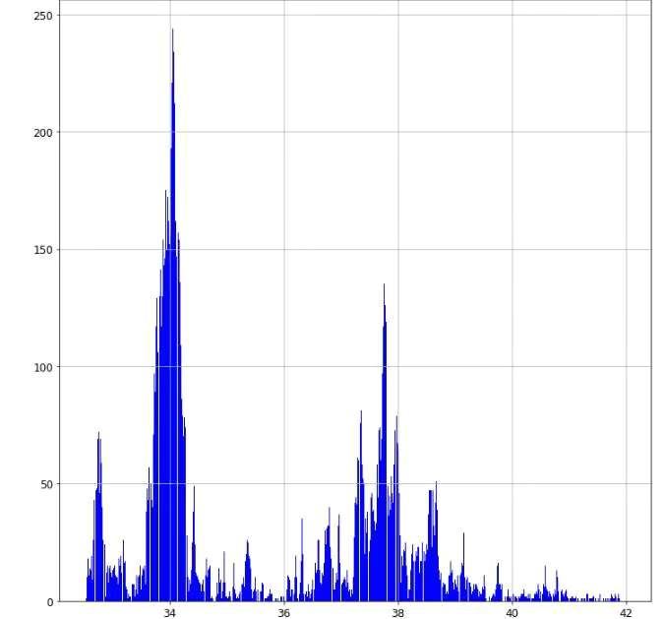
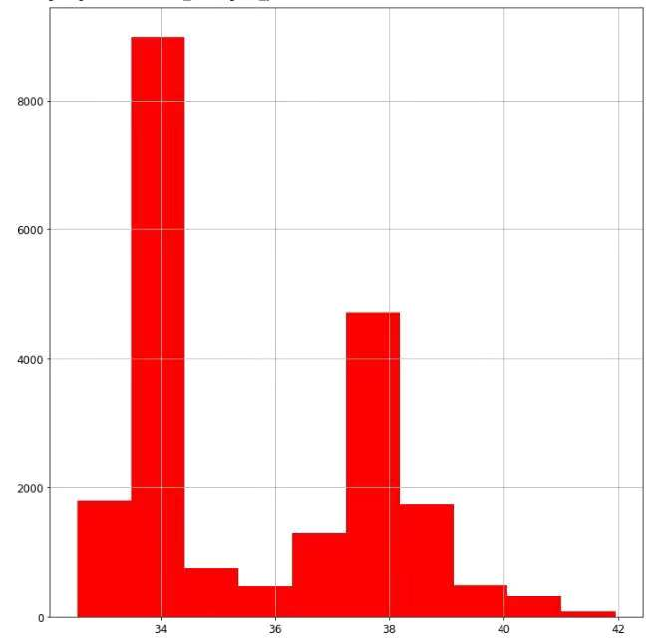
Reference:
https://www.tutorialspoint.com/matplotlib/matplotlib_scatter_plot.htm --Scatter Plot
https://matplotlib.org/3.1.1/api/_as_gen/matplotlib.pyplot.scatter.html -- Scatter Plot
https://matplotlib.org/3.1.1/api/_as_gen/matplotlib.pyplot.hist.html --Histogram
https://github.com/ageron/handson-ml-- github jupyter notebook

