What is Regularization and Why Do We Need it?

When our model is performing very well on training data and not well on validation data, we know we are experiencing overfitting. This can be tackled by using a process known as regularization. This means we add error into our model so that our model becomes more generalized and less prone to only picking up spurious patterns.

Regularization works for any type of problem but our book identifies three common techniques used in linear regression. These methods are:
- Ridges (least error included)
- Lasso (most error included)
- Elastic Net (combination)

Mathematically, these methods can get confusing so let's take a close look at these equations starting with Ridge:

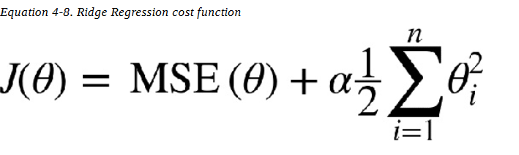

Next is Lasso:
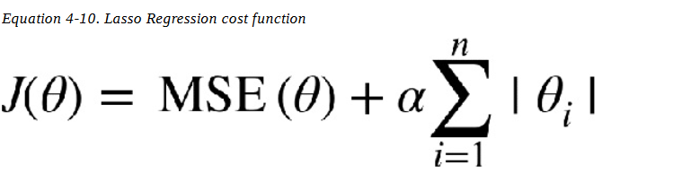

Elastic Net:

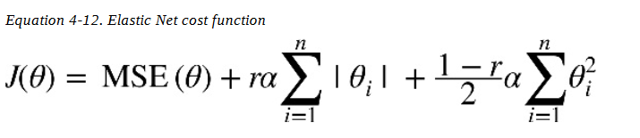

How is the Elastic Net similar to the two techniques?

