(True or False) For each of the sentences below, put the letter T (for true) in the blank if the statement is true. If the statement is false, put the letter F (for false) in the blank.
- ______ In digital electronics, the outputs are normally either in a “high” state or a “low” state.
- ______ In digital electronics, TTL logic is needed to build XOR gates, but CMOS logic can be used to build all other gates.
- ______ In digital electronics, TTL logic gates and CMOS logic gates can be used together without difficulty.
- ______ In digital electronics, all logic gates have two or more inputs.
- ______ In digital electronics, Boolean algebra allows us to ignore the inner workings of the logic gates.
- ______ In digital electronics, a “high” output means that the output voltage is one volt.
- ______ Any truth table can be implemented with a digital circuit (built so that the output of the digital circuit is the same as the truth table.
- ______ The POS (product of sums) implementation of a circuit usually gives the smallest circuit.
- ______ Boolean algebra can be used to reduce the complexity of circuits.
- ______ The Duality Theorem for Boolean algebra says that for every true Boolean algebra theorem, if you simply replace all addition (+) with multiplication (*) (using parentheses to preserve order of operations), replace all addition with multiplication, replace all zeros with ones and all ones with zeros, another true theorem will be formed.
- ______ Minterms describe the conditions of the variables for each line of the truth table.
- ______ The POS (product of sums) implementation of a circuit is the Boolean sum of each of the minterms that makes the function true.
- ______ Any function can be implemented using only NAND gates.
- ______ Any function can be implemented using only OR gates.
- ______ Any function can be implemented using only multiplexers.

Each of the symbols below represents a different type of logic gate. In the column on the right is a list of their names. Match the gate symbol with the correct name by putting the letter corresponding to the name in the blank next to the gate.

- ______
x₁

x₂
output

- ______
x₁

output
x₂

- ______
x₁

x₂
output

- ______
x₁

x₂
output

- ______
x₁

output

- ______
x₁

x₂
output

- ______
x₁

x₂
output

Names of Logic Gates
- AND
- OR
- NAND
- NOR
- NOT
- XOR
- XNOR

a | b | c | output
0 | 0 | 0 | 1
0 | 0 | 1 | 1
0 | 1 | 0 | 0
0 | 1 | 1 | 0
1 | 0 | 0 | 1
1 | 0 | 1 | 1
1 | 1 | 0 | 0
1 | 1 | 1 | 1
- Which of the following functions matches the truth table?
f = ab + abc + ab
f = (a + b + c) (a + b + c) (a + b + c) (a + b + c) (a + b + c)
f = abc + abc + abc
f = abc + abc + abc + abc + abc

- None of the above

(True or False)
- _____ Karnaugh maps contain the same information as a truth table.
- _____ When labeling the columns and rows of Karnaugh maps, only one variable at a time can change values.
- _____ When circling values in Karnaugh maps, the largest number of values should always be circled.
- _____ When circling values in Karnaugh maps, you should never circle a value that has already been circled.
- _____ When circling values in Karnaugh maps, you can loop from top to bottom or from side to side, but not at the same time.
- _____ When a function is incompletely specified, you must finish specifying the function before you can generate a Karnaugh map.
- _____ When circling values in Karnaugh maps, you can circle ones to generate a Product of Sums (POS) function or you can circle zeros to generate a Sum of Products (SOP) function.
- _____ There is no limit to the number of variables that a function can have when a Karnaugh map is used, but it becomes difficult to envision the increasing number of dimensions needed for the map.

- ______ A binary decoder can have any number of outputs if the number is a multiple of two.
- ______ Some binary decoders set the selected output high and all other outputs low while other binary decoders set the selected output low and all other outputs high.
- ______ A failure to properly set any enable bits on a binary decoder causes all outputs to have the same signal.
- ______ Two 2-to-4 binary decoders can be used with only three other logic gates to construct a 3-to-8 binary decoder.
- ______ A 4-to-16 binary decoders can be made using five 2-to-4 binary decoders without requiring any other logic gates.
- ______ The outputs of 74LS138 are the same as the minterms of a function with three input variables.
- ______ In order to best use the 74LS138, the function should be written in terms of its minterms.
- ______ If the outputs of the 74LS138 that correspond to the appropriate minterms are used as inputs to a NAND gate, the 74LS138 will generate the function.
- ______ A multiplexer allows us to choose which one of the inputs to the multiplexer will appear as the output of the multiplexer.
- ______ Any Boolean function can be formed using only 4-to-1 multiplexers.
- ______ Any Boolean function can be formed using only 2-to-1 multiplexers.
- ______ Any three input Boolean function can be formed using only a single 4-to-1 multiplexer.
- ______ Any three input Boolean function can be formed using only a single 2-to-1 multiplexer.

- Using a 74LS163 chip, which of the following creates a base 12 counter?
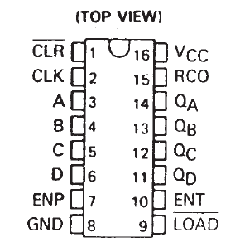
Clock
V_{CC}
1
1
0
0
0
0

a)

Clock
V_{CC}
1
1
0
0
0
0

b)

Clock
V_{CC}
1
1
0
0
0
0

c)

Clock
V_{CC}
1
1
0
0
0
0

d)

e) None of the above

- The multiplexer on the right implements the function corresponding to which truth table?
a | b | c | output
0 | 0 | 0 | 0
0 | 0 | 1 | 1
0 | 1 | 0 | 1
0 | 1 | 1 | 0
1 | 0 | 0 | 1
1 | 0 | 1 | 0
1 | 1 | 0 | 1
1 | 1 | 1 | 1

a)
b
a
f
00
11
01
10
c
1

a | b | c | output
0 | 0 | 0 | 1
0 | 0 | 1 | 0
0 | 1 | 0 | 1
0 | 1 | 1 | 0
1 | 0 | 0 | 0
1 | 0 | 1 | 1
1 | 1 | 0 | 1
1 | 1 | 1 | 1

b)

a | b | c | output
0 | 0 | 0 | 0
0 | 0 | 1 | 0
0 | 1 | 0 | 0
0 | 1 | 1 | 1
1 | 0 | 0 | 1
1 | 0 | 1 | 0
1 | 1 | 0 | 1
1 | 1 | 1 | 1

c)

a | b | c | output
0 | 0 | 0 | 0
0 | 0 | 1 | 1
0 | 1 | 0 | 0
0 | 1 | 1 | 1
1 | 0 | 0 | 1
1 | 0 | 1 | 0
1 | 1 | 0 | 1
1 | 1 | 1 | 1

d)

e) None of the above
- What is the function implemented by the following 74ls138 decoder chip?
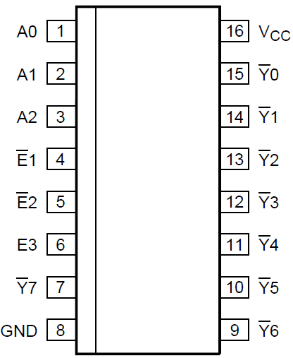
0
0
1
c
a
b

a)
f = ac + bc + ac
f = abc + abc + abc + abc + abc
b)
c)
f = abc + ab + ab
d)
f = ab + abc + ab
e) None of the above

f = x z + x y + x y z
- The function is implemented by which of the following 74ls138 circuits ?
0
0
1
z
x
y

a)

0
0
1
z
x
y

b)

0
0
1
z
x
y

c)

0
0
1
z
x
y

d)

e) None of the above
- Given the following Karnaugh map, which of the following equations best describes the minimized function?
y z
w x
 | 0 0 | 0 1 | 1 1 | 1 0
0 0 | 1 | 0 | 0 | 1
0 1 | 1 | 1 | 1 | d
11 | 0 | d | 0 | 0
1 0 | d | 0 | d | 1
f = w x + x z
a)
f = w x + y z
b)
f = w x + w x z + x y z
c)
f = w x + x z
d)

e) None of the above

- Given the following Karnaugh map, which of the following equations best describes the minimized function?
y z
w x
 | 0 0 | 0 1 | 1 1 | 1 0
0 0 | 1 | 0 | 0 | 1
0 1 | 1 | 1 | 1 | d
11 | 0 | d | 0 | 0
1 0 | d | 0 | d | d
f = ( w + x ) ( w + z )
a)
f = ( w + x ) (w + x + z )
b)
f = w x + w z
c)
f = w (x + z )
d)

e) None of the above

